Guide to simulating capacitance using Q3D Extractor

1. Open Q3D Extractor
2. Click “Project” in the bar at the top, and then choose “Insert Q3D Extractor Design”. Your screen should look like this:

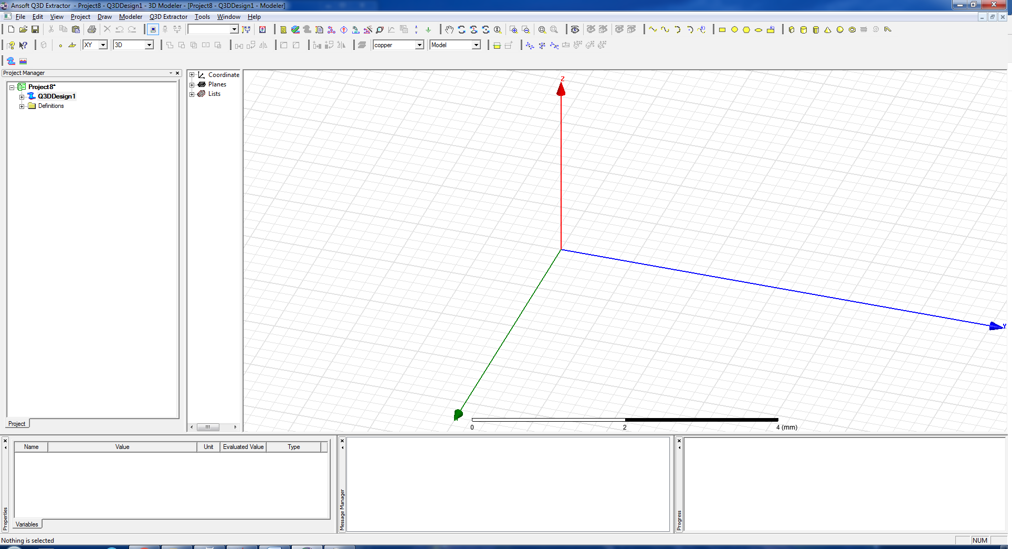

1. To import your design click “Modeler” (at the top) and choose “Import”. Select your design file. The “DXF/DWG Import” window will open. Un-check the box next to “PYDXF”. Click the “Options” tab, and set the “Override” units to micrometers (um). Check the box next to “Import as 2D sheet bodies”. Hit “OK”.

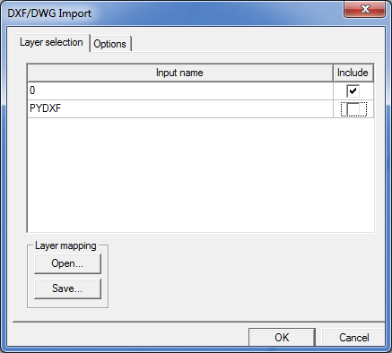 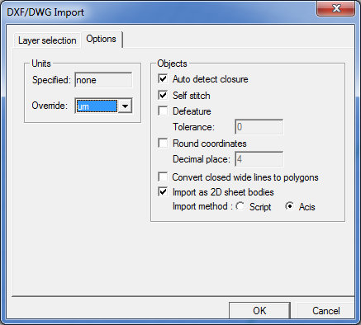

1. Delete the objects from your design that you do not want to include in the capacitance simulation by highlighting them with your cursor and pressing “Delete” on the keyboard. An example “before” and “after” are shown below.

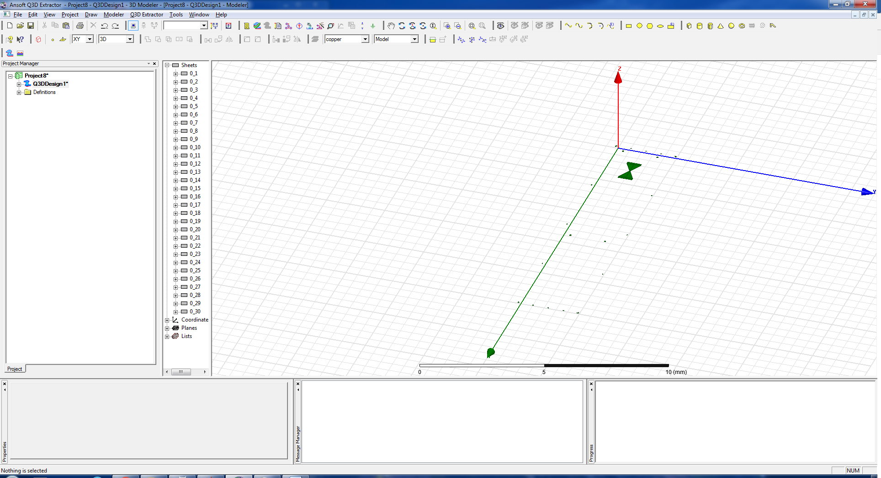

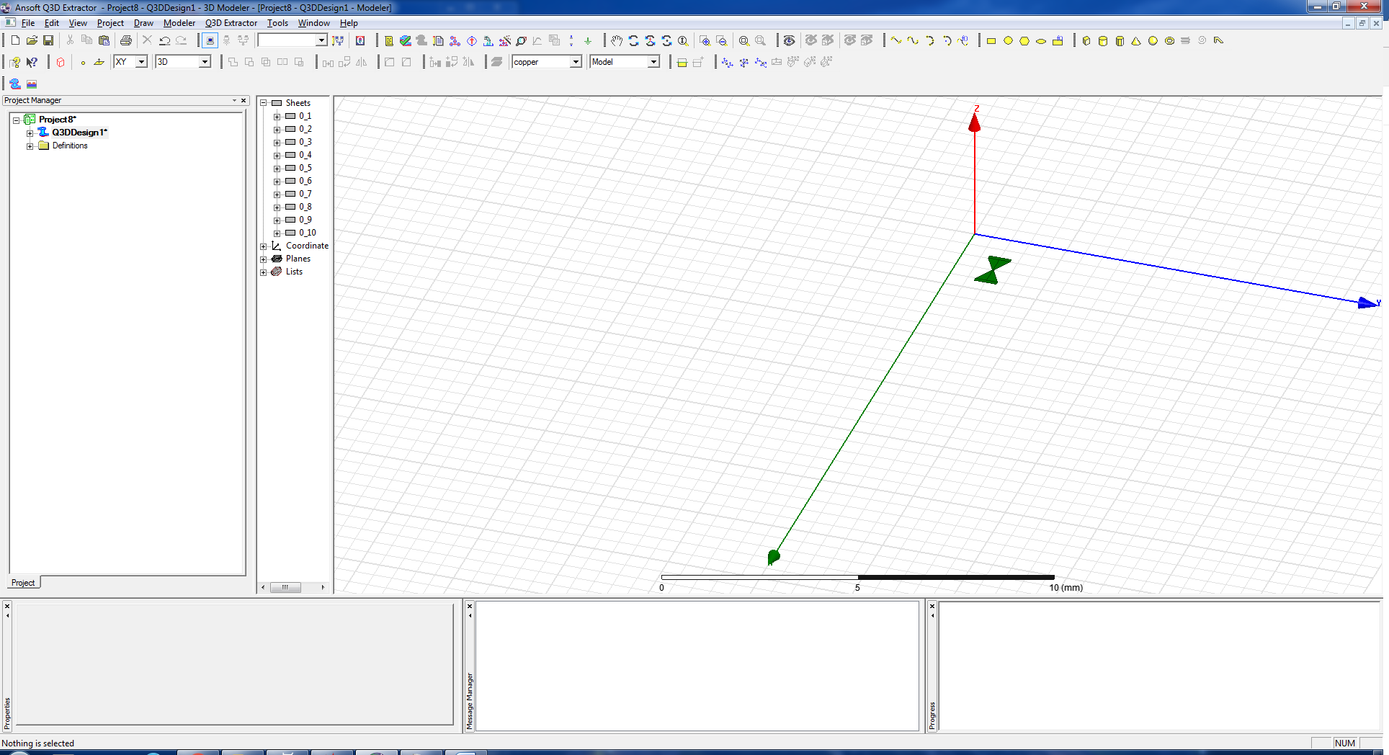

1. Highlight the remaining objects with your cursor. Right click on them and select:

>> “Edit”

>> “Boolean”

>> “Unite”

This will make the objects into continuous shapes.

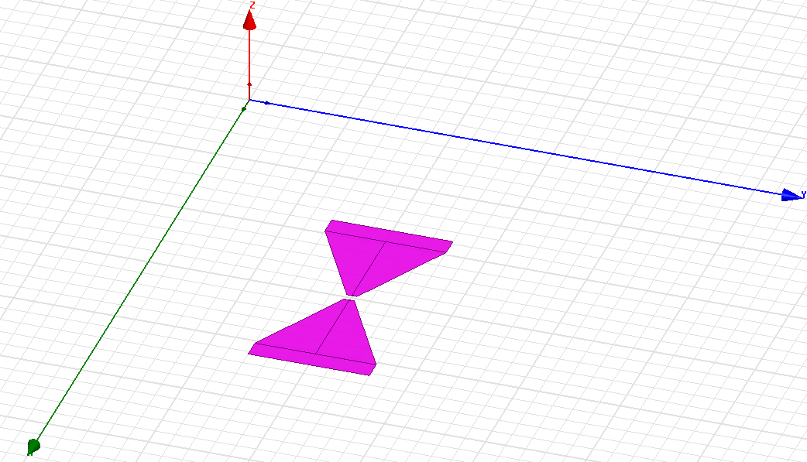 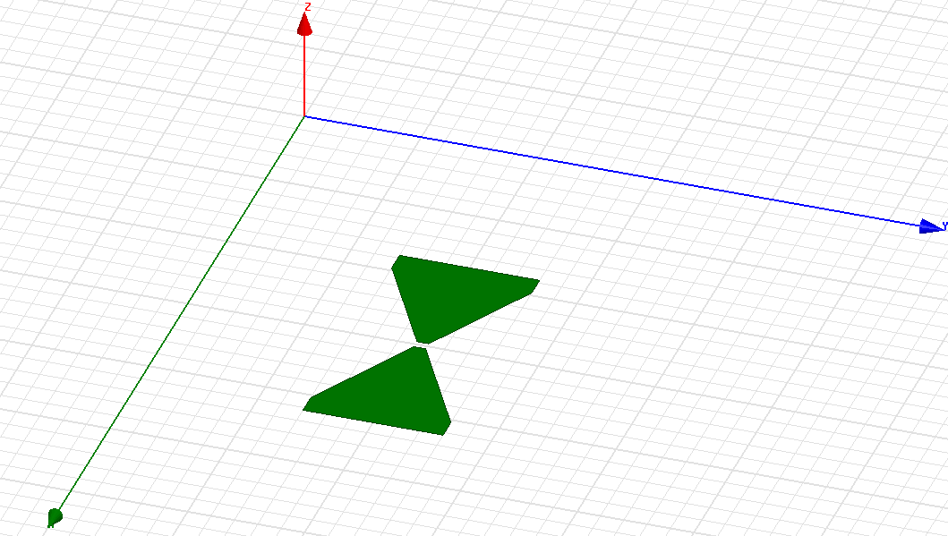

1. Right anywhere and choose “Select Faces”. Highlight the objects again, right click on them, and click:

>> “Edit”

>> “Surface”

>> “Sweep Faces Along Normal”

When the window (shown below) pops up, set the “Length of Sweep” to the thickness of your design, then click “OK”.

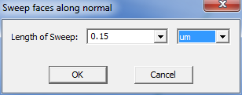

1. In the column to the left, expand the “Solids” and “Not Assigned” tabs.

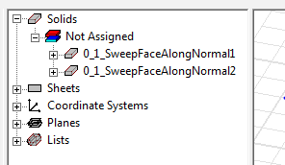

Double-click on each of the solids listed under “Not Assigned”. In the “Properties” window that pops up, click the box next to “Material” and select “Edit”. Scroll down the list of materials until you find “Perfect Conductor” and select it. Hit “Ok” to exit the “Properties” window. Do this for all of the solids you created in the previous step.

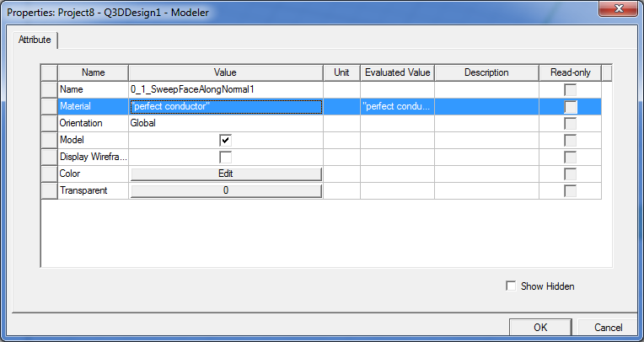

1. To model the substrate that your objects will be on, go to “Draw” in the menu at the top of the screen and click on “Box”. Use the cursor to draw a rectangle around your objects, then drag the cursor down to create the chip under them.

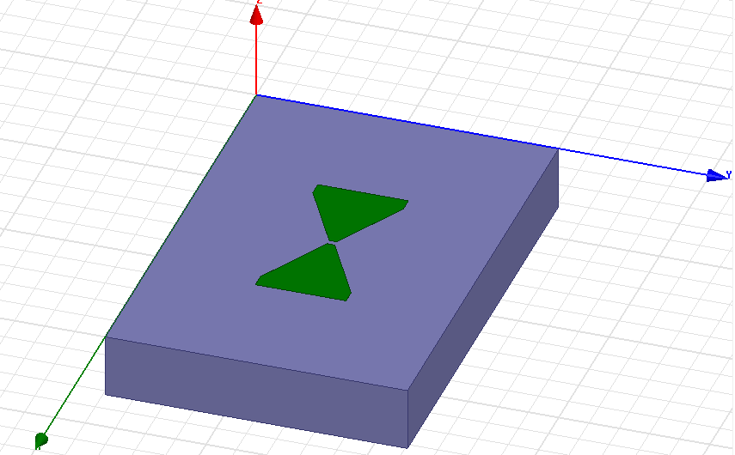

In the column to the left, expand the new solid you just created and double click on “CreateBox”. The “Properties” window (shown below) will pop up. In the box next to “ZSize” enter the thickness of your wafer (negative sign so that it is under your objects), and, if applicable, the units.

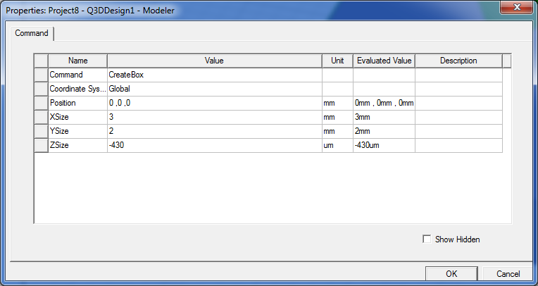

Double-click on the box you just created, and adjust the material, like before. This time choose the appropriate material for your wafer (silicon, sapphire, etc.).

1. To add a column of vacuum above and below your wafer, draw boxes above and below the chip you just created.

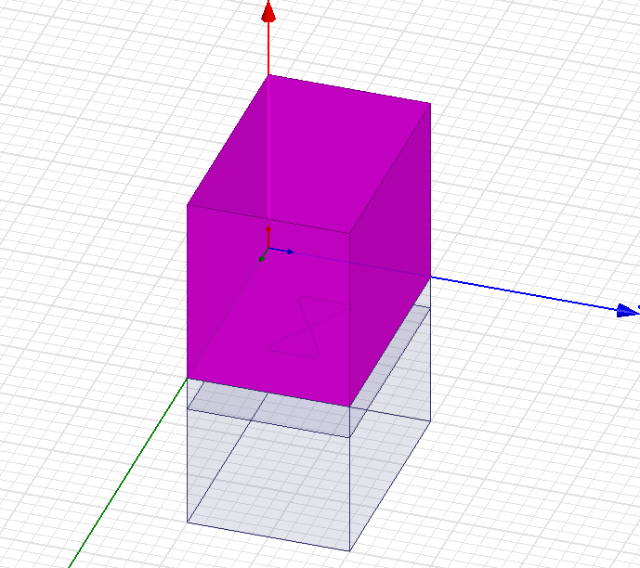

Like before, change the height of these boxes by double-clicking “CreateBox” under their headings in the column to the left. Set the height to be the size of the vacuum on either side of the chip when it’s in the cavity. Change the material of these two new boxes from “copper” to “vacuum”, also.

Optional: In order to the objects you want to measure the capacitance of visible again, you can highlight the top vacuum box by clicking on it in the “Solids” tree. Right click on the highlighted object; then select:

>> “View”

>> “Hide Selection”

1. In the far left column, under your project, expand “Q3DDesign”. Right-click on “Nets” and select “Auto Identify Nets”. Now you will be able to expand under “Nets”. Click on each of the nets listed to make sure they cover all of the objects in your design.

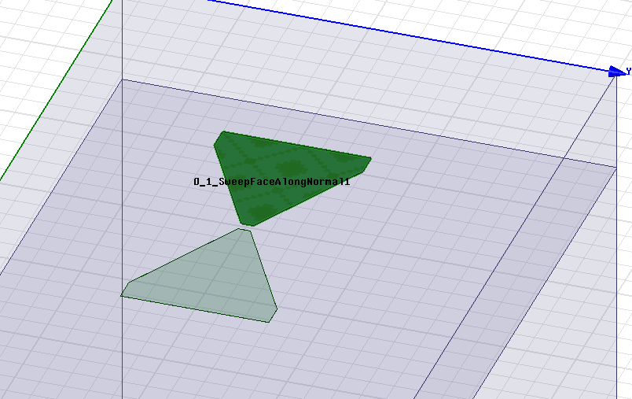

1. Right-click on “Analysis” (again in the far-left column), and choose “Add Solution Setup…”. This will cause the “Solve Setup” window to pop up. Set the “Solution Frequency” to 10GHz. Un-check the boxes next to “DC” and “AC”. Then click on the “CG” tab and set the “Maximum Number of Passes” to a high number, and change the “Maximum Number Converged Passes” to more than 1. Click “OK” to exit the window. Expand under “Analysis”, to show “Setup1”.

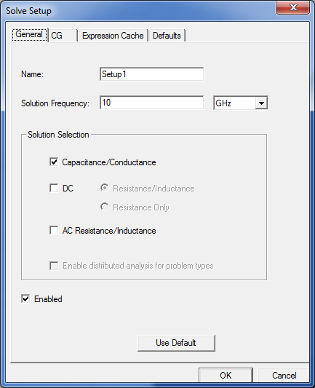 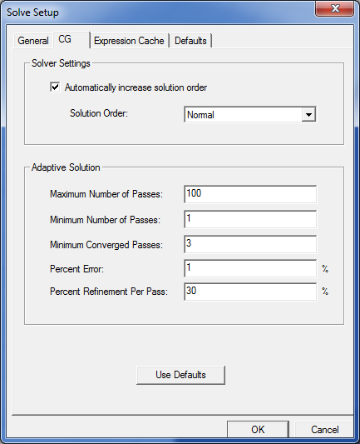

1. Highlight all of the boxes and objects again, and right-click on “Setup1”. Select “Analyze”. A window will pop up asking you to save your project. After doing this, the simulation will run. This may take a while, so DON’T PANIC. If the simulation was successful, you will get a notification at the bottom of the screen:

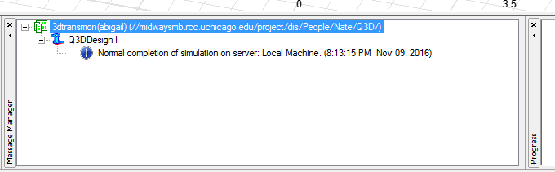

1. To view the solution, go to the far-left column again, and right-click on “Results” under “Analysis”. Select “Solution Data…” from the menu. This will bring up the solutions window (shown below).

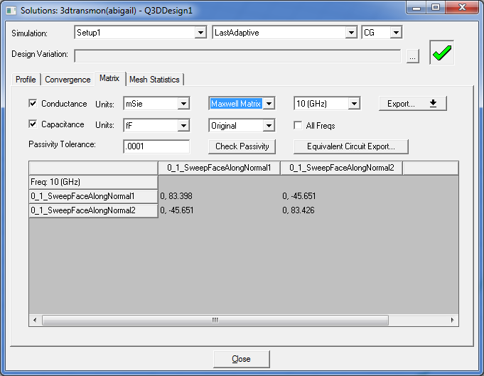

Change the Capacitance units to “fF”. The off-diagonal terms in the matrix (circled in red) represent the capacitance between the objects.